Name _________________________________________________________ Period ___________
Revision Piece
Occasionally during the year, students will revise a written piece already submitted and graded. Unless otherwise directed, all revision pieces may be selected by the student. Depending upon the revision assignment, the focus of the revision may also be selected by the student [eg, may choose to focus on syntax and sentence openers or embedding evidence] or by the teacher. The focus must be stated on the appropriate lines. All revised pieces must have the graded copy attached prior to submission.
Assignment: _______________________________________________________________________
Teacher/Student Selected Revision Focus: ___________________________________________
____________________________________________________________________________________
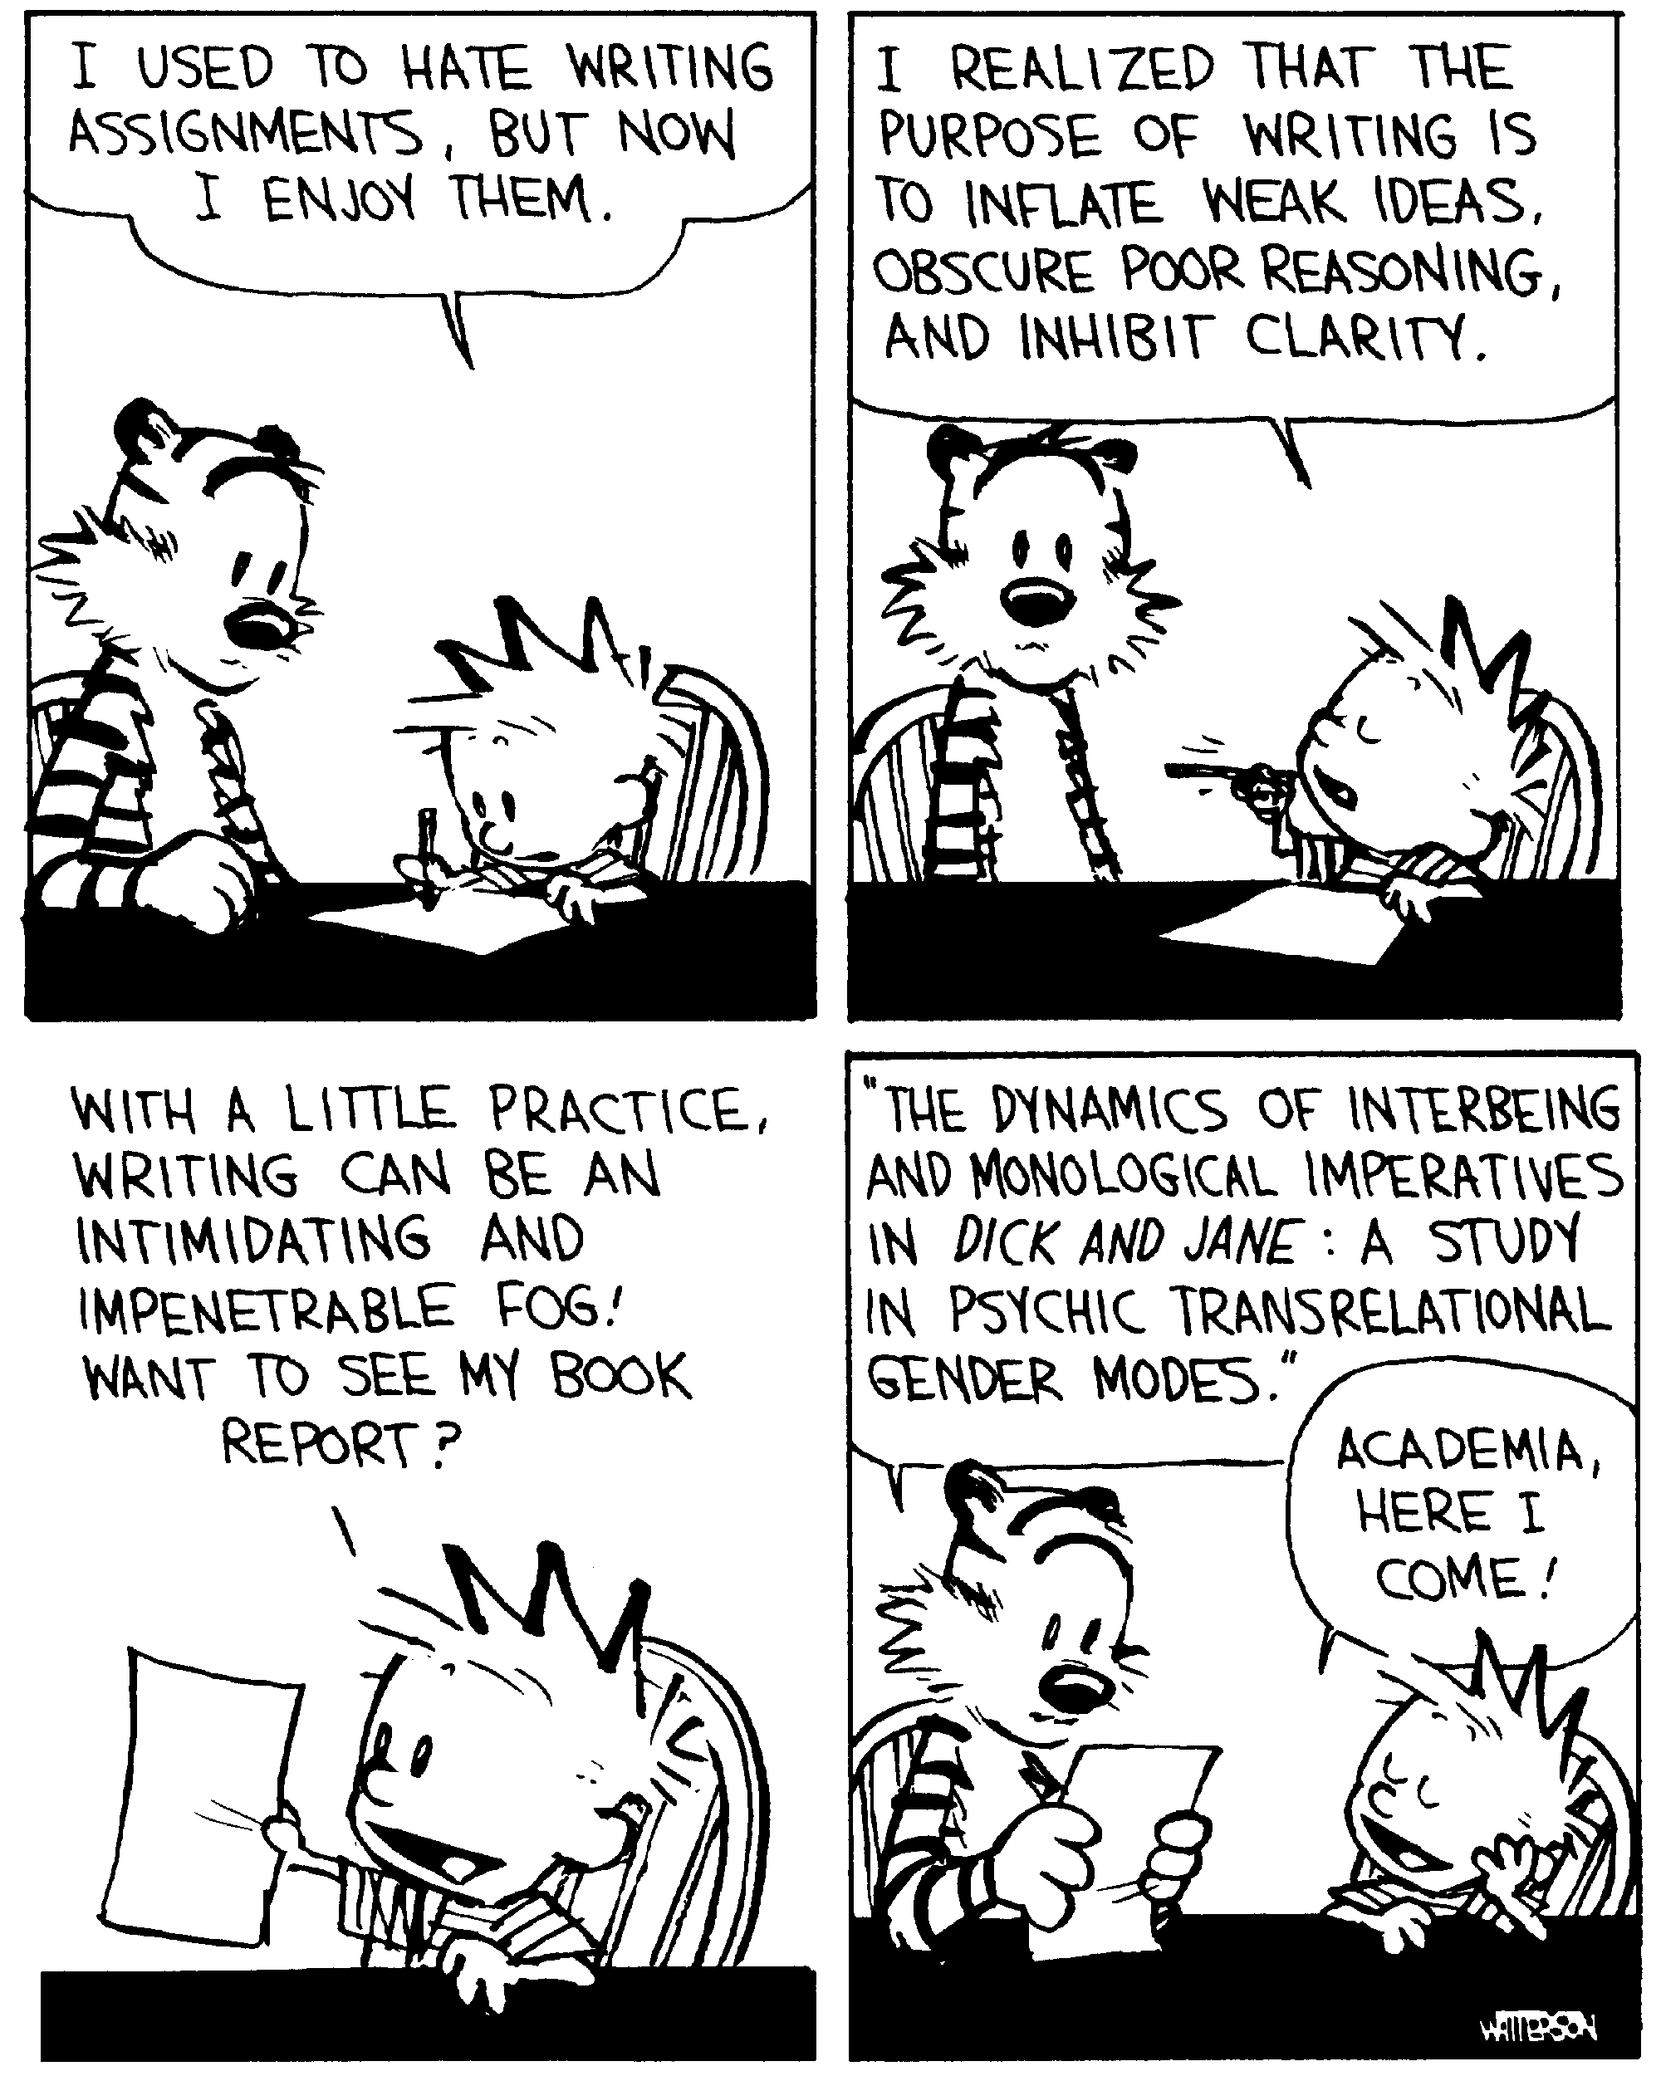
Due Date ____________________________________

