The Crucible
Writing Assignment
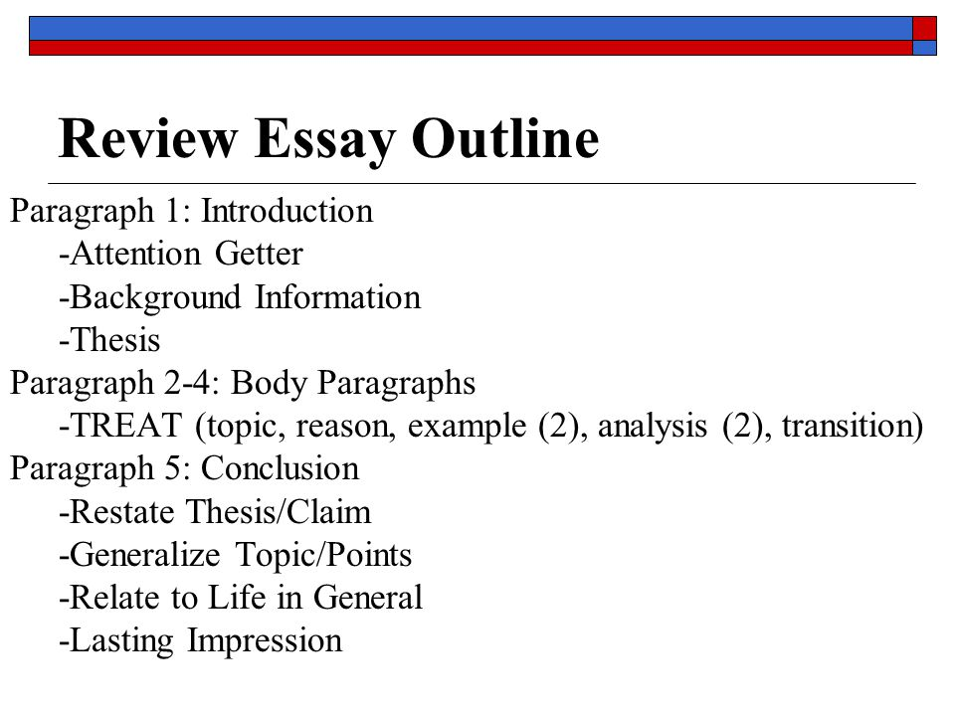
For your final essay on The Crucible, please write a five paragraph, analytical essay in which you trace one of the themes from the beginning of the play to the end.
Paragraph 1: introduction – the intro needs to explain the theme the paper will develop. The thesis should include the three devices from the analytical paragraphs. (15 points)
Paragraph 2: Analytical paragraph one character who develops the theme with his or her personality trait. (20 points)
Paragraph 3: Analytical paragraph one conflict which develops the theme - you can choose to use internal or external conflict. (20 Points)
Paragraph 4: Analytical paragraph with one symbol or archetype that develops the theme (20 points)
Paragraph 5: Conclusion (10 points)
Mechanics: (15 points) – NO – personal pronouns – YOU – contractions – GET, VERY, SHOW - Pay attention to the sentence structure and word choice to avoid repetition.

Requirements -Your essay must be at least five paragraphs in length.
-Your essay must have a clear thesis that responds to the prompt and presents a claim.
- It must be typed, double spaced, with one inch margins, in size 12, Times New Roman font.
- It must be submitted to turnitin.com

Guidelines: An analytical essay provides your perspective on a piece of literature. Think of your paper as the fulfillment of the following goals:
1. You want to communicate what you have learned about Arthur Miller’s play.
2. You should create a claim or argument that provides your response to one of the prompts.
3. You must show that your claim is supported by the text.
4. You need to show that your view of this idea is correct.
5. You need to illustrate that this idea reaches beyond the pages of The Crucible.

These five goals represent the five elements of your paper. The first two - information on your topic, the author, the play and your thesis - are discussed in your introduction. The next two –a discussion of how your examples support your thesis and evidence from the text - are examined in your body paragraphs. The last one - a synthesis of your analysis - is presented in your conclusion.

Introduction:
Hook 5 3 2
Background 5 3 2
Thesis: 5 3 2
Analytical 1:
Topic Sentence: 5 3 2
Evidence: 5 3 2
Analysis: 5 3 2
Transitions: 5 3 2
Analytical 2:
Topic Sentence: 5 3 2
Evidence: 5 3 2
Analysis: 5 3 2
Transitions: 5 3 2
Analytical 3:
Topic Sentence: 5 3 2
Evidence: 5 3 2
Analysis: 5 3 2
Transitions: 5 3 2
Conclusion:
Restatement 3 2
Relate to Life 4 3 2
Last impression 3 2
Mechanics:
_________/15

TOTAL:______________/100

Introduction:
Hook 5 3 2
Background 5 3 2
Thesis: 5 3 2
Analytical 1:
Topic Sentence: 5 3 2
Evidence: 5 3 2
Analysis: 5 3 2
Transitions: 5 3 2
Analytical 2:
Topic Sentence: 5 3 2
Evidence: 5 3 2
Analysis: 5 3 2
Transitions: 5 3 2
Analytical 3:
Topic Sentence: 5 3 2
Evidence: 5 3 2
Analysis: 5 3 2
Transitions: 5 3 2
Conclusion:
Restatement 3 2
Relate to Life 4 3 2
Last impression 3 2
Mechanics:
_________/15

TOTAL:______________/100

