American Literature
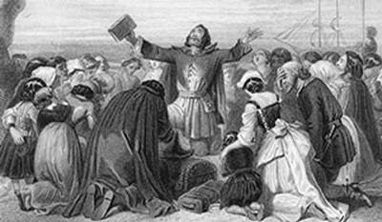
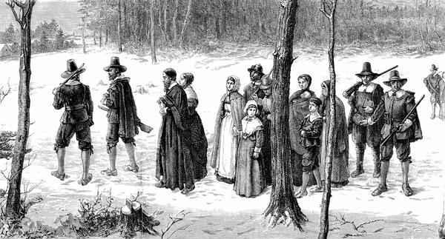
Unit 1: Encounters and Foundations to 1800
“For we must consider that we shall be as a city upon a hill, the eyes of all people are upon us. So that if we shall deal falsely with our God in this work we have undertaken, and so cause Him to withdraw His present help from us, we shall be made a story and a byword through the world…”
~ John Winthrop, from a sermon aboard the Arabella,
on the way to New England, spring 1630
- “Encounters and Foundations to 1800 (Arpin)
- “Here Follows…Upon Burning Of Our House” (Bradstreet)
- “To My Dear and Loving Husband” (Bradstreet)
- from Sinners in the Hands of an Angry God (Edwards)
- The Crucible (Miller)
- “Speech to the Virginia Convention” (Henry)

