American Literature
Unit 3: The Rise of Realism
“Whenever you find yourself on the side of the majority, it is time to pause and reflect.”
~Mark Twain

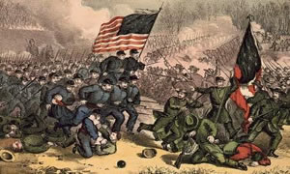

- “The Rise of Realism” (Arpin)
- Excerpt from “Narrative of the Life of Frederick Douglass” (Douglass)
- “An Occurrence at Owl Creek Bridge” (Bierce)
- “A Pair of Silk Stockings” (Chopin)

